Mirror Backup

Definition
# Source: AI Source: Provided by: [Data Path: Persons Table -> ID Column: 1, Name_En Column: Motasem Essam] -> From: [Chatgpt (GPT‑5 Mini)] on [12/10/2025]
A Mirror Backup is a type of backup that creates an exact copy of the source data. Every file in the original location is duplicated in the backup location without compression, and the backup reflects real-time changes.

Key Idea
# Source: AI Source: Provided by: [Data Path: Persons Table -> ID Column: 1, Name_En Column: Motasem Essam] -> From: [Chatgpt (GPT‑5 Mini)] on [12/10/2025]
Mirror backups are designed to provide instant access to an exact replica of your data, making it easy to recover individual files quickly. Unlike other backup types, older versions may not be kept unless versioning is specifically enabled.

How It Works
# Source: AI Source: Provided by: [Data Path: Persons Table -> ID Column: 1, Name_En Column: Motasem Essam] -> From: [Chatgpt (GPT‑5 Mini)] on [12/10/2025]
- Select the data or folder to be mirrored.
- Copy all files to the backup location exactly as they exist.
- Update the backup whenever changes occur in the source (new files, modified files, deleted files).
- Optionally, enable versioning to keep older copies of files.

Example
# Source: AI Source: Provided by: [Data Path: Persons Table -> ID Column: 1, Name_En Column: Motasem Essam] -> From: [Chatgpt (GPT‑5 Mini)] on [12/10/2025]
- A server directory containing current project files is mirrored to another server so that any updates are immediately reflected in the backup.
- Personal files on a computer are mirrored to an external drive nightly to ensure an exact copy is always available.

Advantages
# Source: AI Source: Provided by: [Data Path: Persons Table -> ID Column: 1, Name_En Column: Motasem Essam] -> From: [Chatgpt (GPT‑5 Mini)] on [12/10/2025]
- Provides an exact, real-time replica of your data.
- Easy to access individual files without restoring an entire backup.
- Useful for fast recovery and high availability.

Disadvantages
# Source: AI Source: Provided by: [Data Path: Persons Table -> ID Column: 1, Name_En Column: Motasem Essam] -> From: [Chatgpt (GPT‑5 Mini)] on [12/10/2025]
- No built-in versioning by default, so deleted or corrupted files in the source may be lost in the backup.
- Requires as much storage as the source data.
- Does not protect against accidental deletion or corruption unless combined with versioning or snapshots.

Full Backup vs Mirror Backup

1️⃣ Full Backup
# Source: AI Source: Provided by: [Data Path: Persons Table -> ID Column: 1, Name_En Column: Motasem Essam] -> From: [Chatgpt (GPT‑5 Mini)] on [12/10/2025]
- What it is: A complete copy of all data at a specific point in time.
- Key point: Each backup preserves everything as it was at that moment, and you can keep multiple backups from different times.
- Example:
  - Sunday: Full backup of all company files.
  - Monday: Another full backup could be made if needed.
- Advantage: You can restore data from any backup point in the past.
- Disadvantage: Takes longer to create and requires more storage if multiple backups are kept.

2️⃣ Mirror Backup
# Source: AI Source: Provided by: [Data Path: Persons Table -> ID Column: 1, Name_En Column: Motasem Essam] -> From: [Chatgpt (GPT‑5 Mini)] on [12/10/2025]
- What it is: An exact copy of the source data, often updated in real time.
- Key point: The mirror always reflects the current state of the data, usually keeping only one copy.
- Example:
  - A project folder on a server is mirrored to another server.
  - Any new file or modification appears immediately in the mirrored copy.
- Advantage: Provides instant access to the current version of data.
- Disadvantage: If a file is deleted or corrupted in the source, the same happens in the mirror; no version history unless versioning is enabled.

Easy Way to Remember
# Source: AI Source: Provided by: [Data Path: Persons Table -> ID Column: 1, Name_En Column: Motasem Essam] -> From: [Chatgpt (GPT‑5 Mini)] on [12/10/2025]
- Full Backup = Snapshot → Periodic complete copy, can keep multiple historical versions.
- Mirror Backup = Exact Copy → Real-time copy, reflects current data, usually only one version.

Summary
# Source: AI Source: Provided by: [Data Path: Persons Table -> ID Column: 1, Name_En Column: Motasem Essam] -> From: [Chatgpt (GPT‑5 Mini)] on [12/10/2025]
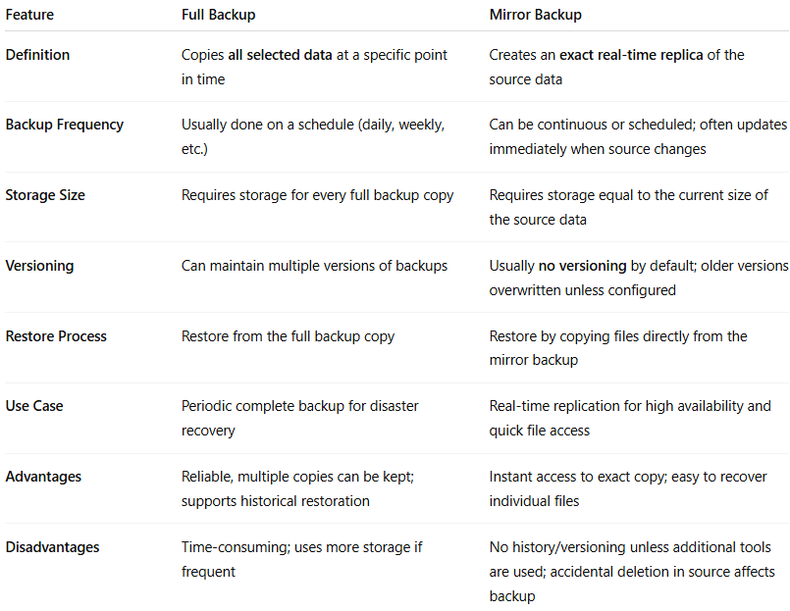
Feature | Full Backup | Mirror Backup
Definition | Copies all selected data at a specific point in time | Creates an exact real-time replica of the source data
Backup Frequency | Usually done on a schedule (daily, weekly, etc.) | Can be continuous or scheduled; often updates immediately when source changes
Storage Size | Requires storage for every full backup copy | Requires storage equal to the current size of the source data
Versioning | Can maintain multiple versions of backups | Usually no versioning by default; older versions overwritten unless configured
Restore Process | Restore from the full backup copy | Restore by copying files directly from the mirror backup
Use Case | Periodic complete backup for disaster recovery | Real-time replication for high availability and quick file access
Advantages | Reliable, multiple copies can be kept; supports historical restoration | Instant access to exact copy; easy to recover individual files
Disadvantages | Time-consuming; uses more storage if frequent | No history/versioning unless additional tools are used; accidental deletion in source affects backup

